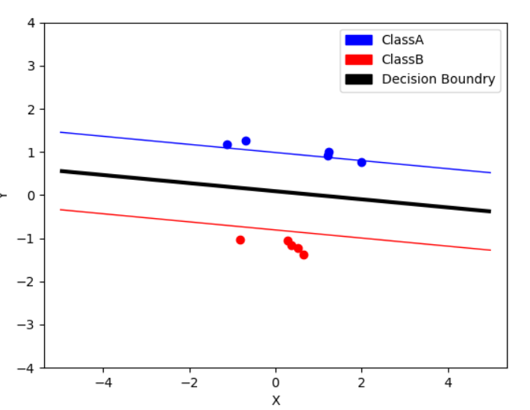

For Linear Kernel with C = 0.1

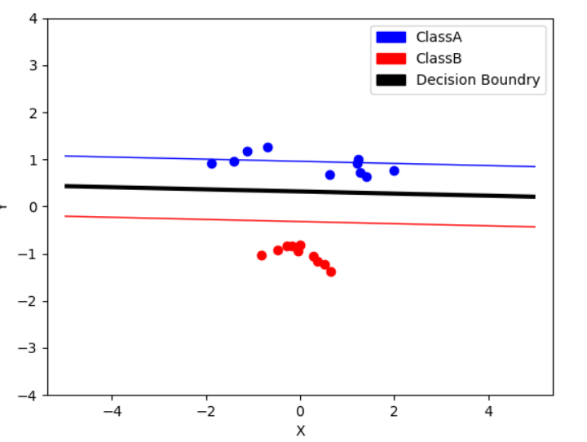

For Linear Kernel with C=0.5

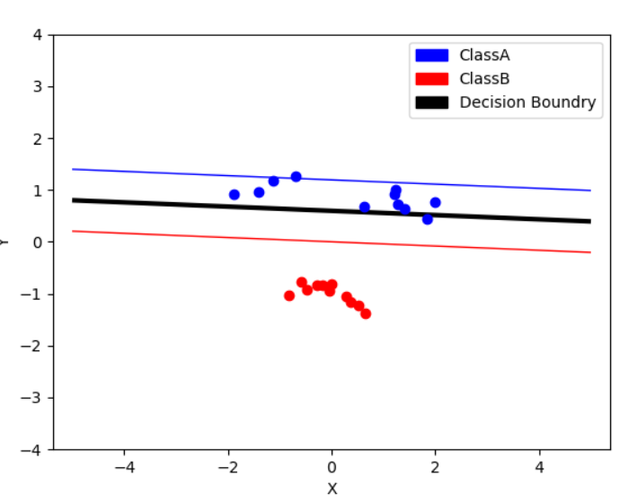

For Linear Kernel with C=1

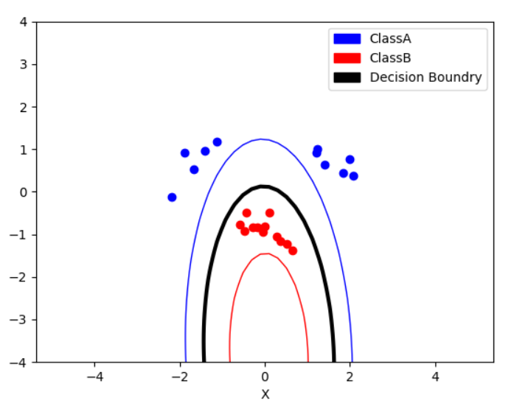

For polynomial (2) Kernel with C=0.1

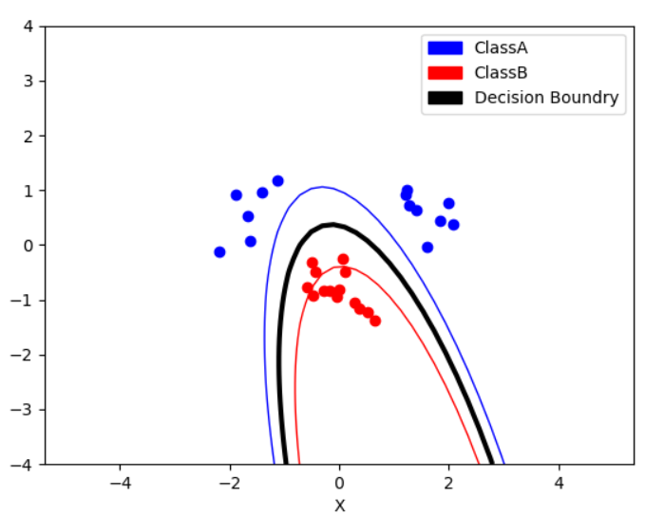

For Polynomial (2) with C=0.5

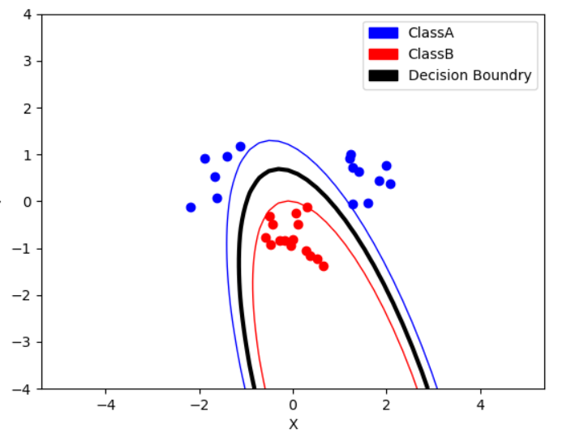

For polynomial (2) Kernel with C=1

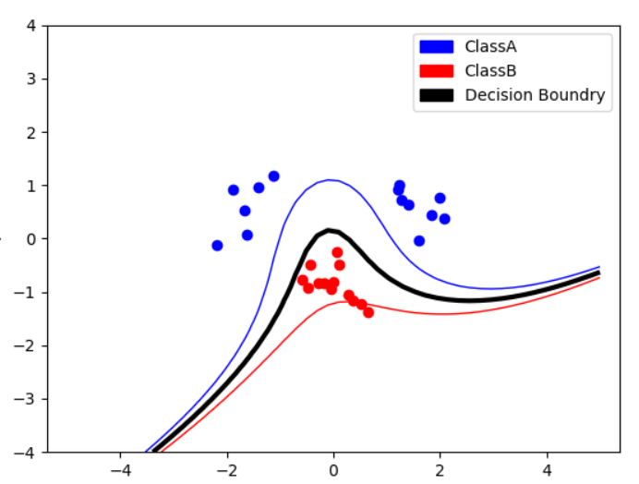

For Polynomial Kernel 3 with C=0.1

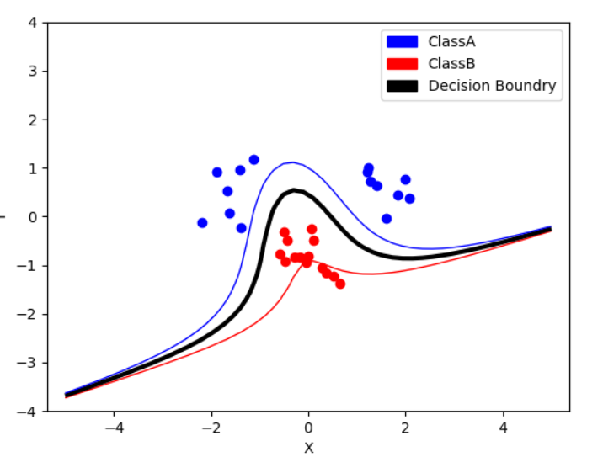

For polynomial (3) Kernel with C=0.5

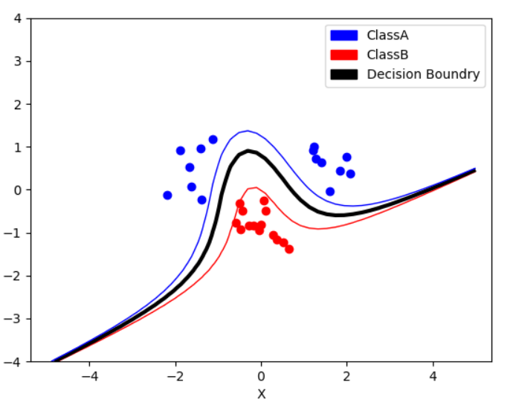

For Polynomial(3) Kernel with C=1